TASK 2- DIGITAL PORTFOLIO
LINKEDIN-

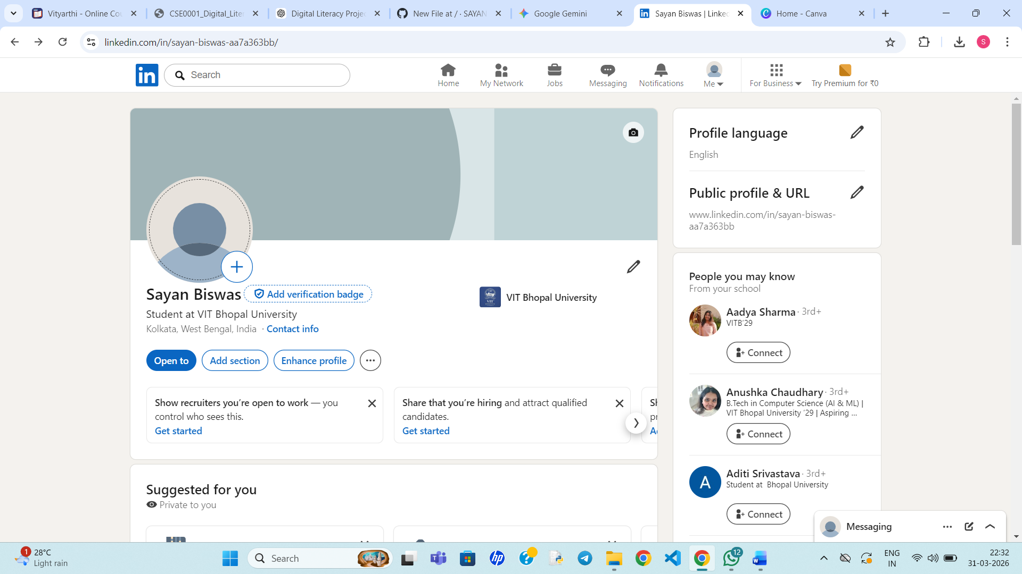

GITHUB-

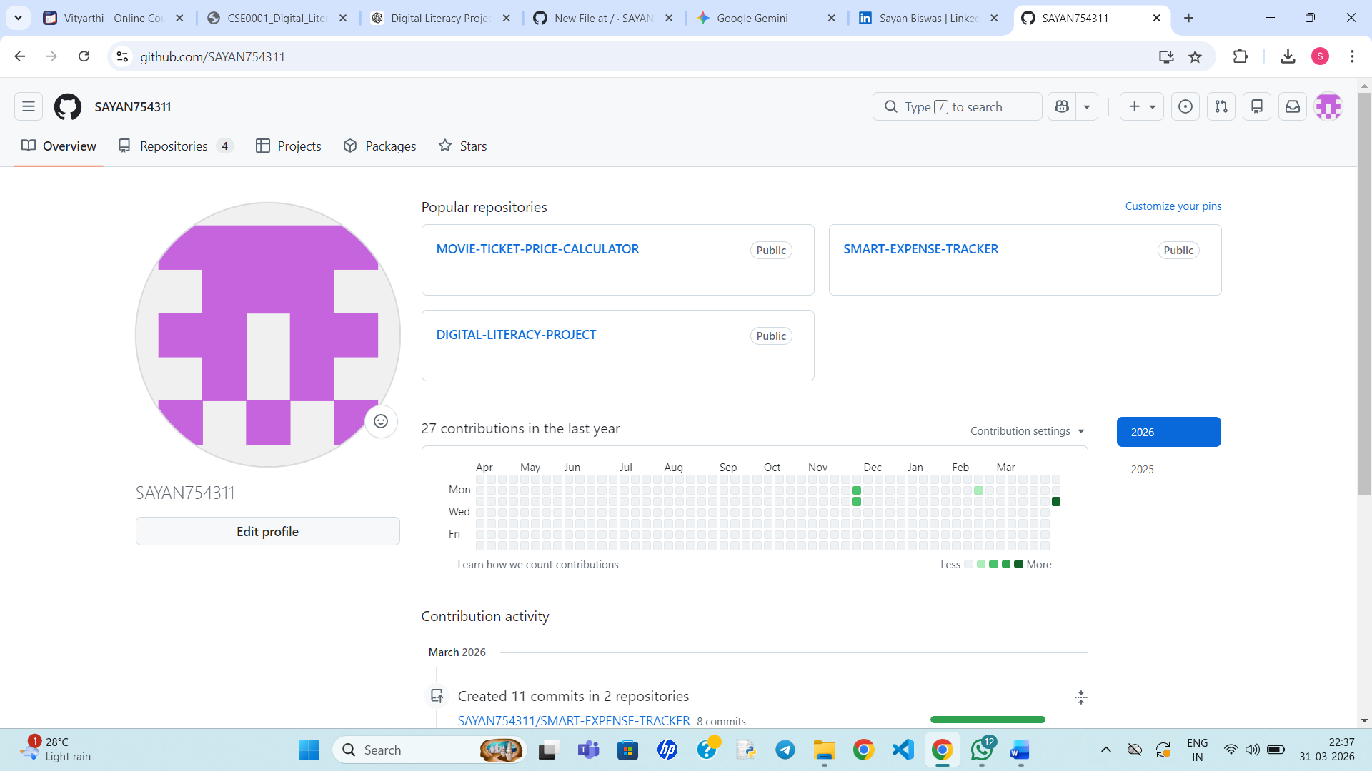

RESEARCHGATE-

